# Lab: Associative Arrays

Problems for exercise and homework for the ["JS Fundamentals" Course @ SoftUni.](https://softuni.bg/trainings/3449/programming-fundamentals-with-javascript-september-2021)   
Submit your solutions in the SoftUni judge system at: <https://judge.softuni.org/Contests/1231>

## Phone Book

Write a function that stores information about a **person’s name** and his **phone number**. The input comes as an **array of strings**. Each string contains the name and the number. If you receive the same name **twice** just **replace** the number. At the end print the result **without sorting it**. Try using an **associative array.**

### Example

|  |  |
| --- | --- |
| **Input** | **Output** |
| **['Tim 0834212554',**  **'Peter 0877547887',**  **'Bill 0896543112',**  **'Tim 0876566344']** | **Tim -> 0876566344**  **Peter -> 0877547887**  **Bill -> 0896543112** |
| **['George 0552554',**  **'Peter 087587',**  **'George 0453112',**  **'Bill 0845344']** | **George -> 0453112**  **Peter -> 087587**  **Bill -> 0845344** |

## Meetings

Write a function that manages meeting appointments. The input comes as an **array of strings**. Each string contains a **weekday** and person’s **name**. For each **successful** meeting, **print a message**. If you receive the **same weekday** twice, the meeting cannot be scheduled so print a **conflict message**. At the end print a list of all **successful** meetings. See example for message format and details.

### Example

|  |  |
| --- | --- |
| **Input** | **Output** |
| **['Monday Peter',**  **'Wednesday Bill',**  **'Monday Tim',**  **'Friday Tim']** | **Scheduled for Monday**  **Scheduled for Wednesday**  **Conflict on Monday!**  **Scheduled for Friday**  **Monday -> Peter**  **Wednesday -> Bill**  **Friday -> Tim** |
| **['Friday Bob',**  **'Saturday Ted',**  **'Monday Bill',**  **'Monday John',**  **'Wednesday George']** | **Scheduled for Friday**  **Scheduled for Saturday**  **Scheduled for Monday**  **Conflict on Monday!**  **Scheduled for Wednesday**  **Friday -> Bob**  **Saturday -> Ted**  **Monday -> Bill**  **Wednesday -> George** |

## Address Book

Write a function that stores information about a person’s **name** and his **address**. The input comes as an **array of strings**. Each string contains the **name** and the **address** separated by a **colon**. If you receive the same name **twice** just **replace** the address. At the end print the full list, **sorted alphabetically** by the person’s name.

|  |  |
| --- | --- |
| **Input** | **Output** |
| **['Tim:Doe Crossing',**  **'Bill:Nelson Place',**  **'Peter:Carlyle Ave',**  **'Bill:Ornery Rd']** | **Bill -> Ornery Rd**  **Peter -> Carlyle Ave**  **Tim -> Doe Crossing** |
| **['Bob:Huxley Rd',**  **'John:Milwaukee Crossing',**  **'Peter:Fordem Ave',**  **'Bob:Redwing Ave',**  **'George:Mesta Crossing',**  **'Ted:Gateway Way',**  **'Bill:Gateway Way',**  **'John:Grover Rd',**  **'Peter:Huxley Rd',**  **'Jeff:Gateway Way',**  **'Jeff:Huxley Rd']** | **Bill -> Gateway Way**  **Bob -> Redwing Ave**  **George -> Mesta Crossing**  **Jeff -> Huxley Rd**  **John -> Grover Rd**  **Peter -> Huxley Rd**  **Ted -> Gateway Way** |

## Storage

Write a function that takes a certain number of **items** and their **quantity**. If the same item appears **more than once**, **add the new amount** to the **existing one**. At the end print all the items and their amount without sorting them. The input comes as **array of strings**. Try using a Map().

### Example

|  |  |
| --- | --- |
| **Input** | **Output** |
| **['tomatoes 10',**  **'coffee 5',**  **'olives 100',**  **'coffee 40']** | **tomatoes -> 10**  **coffee -> 45**  **olives -> 100** |
| **['apple 50',**  **'apple 61',**  **'coffee 115',**  **'coffee 40']** | **apple -> 111**  **coffee -> 155** |

### Hints

Create the solve() function and create a new Map():

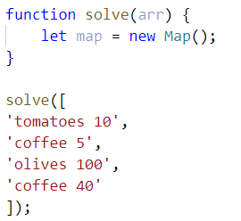

Loop through the array, split into tokens and create variables for each one:

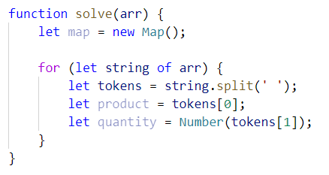

* This time for the quantity we need a number, because if we see the same product again, we must add the new quantity

Now let us make the checks for the keys in the map:

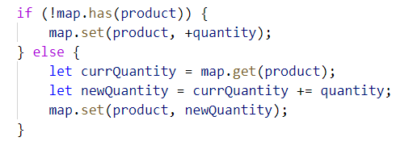

* First, we check if the map does ***NOT*** have the product we are currently at and **if so**, we **set it to the given quantity**
* Otherwise, we get the **existing quantity**, we **add the new quantity** and **set** the product’s quantity **to the new** one

Now we just have to print the result:

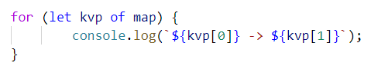

* Each key-value pair is and **array of 2 elements** (the **key** and the **value**), so we use **for-of** loop and print the key and the value

## School Grades

Write a function to store students with all of their grades. If a student appears more than once, add the new grades. At the end print the students sorted by average grade. The input comes as **array of strings**.

### Example

|  |  |
| --- | --- |
| **Input** | **Output** |
| **['Lilly 4 6 6 5',**  **'Tim 5 6',**  **'Tammy 2 4 3',**  **'Tim 6 6']** | **Tammy: 2, 4, 3**  **Lilly: 4, 6, 6, 5**  **Tim: 5, 6, 6, 6** |
| **['Steven 3 5 6 4',**  **'George 4 6',**  **'Tammy 2 5 3',**  **'Steven 6 3']** | **Tammy: 2, 5, 3**  **Steven: 3, 5, 6, 4, 6, 3**  **George: 4, 6** |

### Hints

Create the function, pass in the array, **split** each element into tokens, **extract** the **name** andthe **grades**:

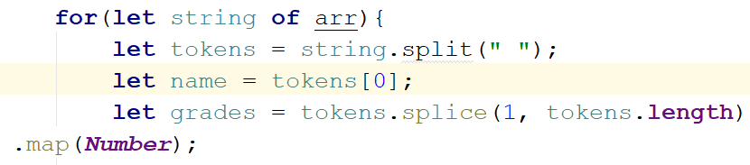

* The **grades** should be **numbers** (because we want to take the **average** later), so we map them toNumber

Now check if the map does ***NOT*** have the name and if so, **set it to an empty array** and **push all the grades**. Otherwise just **push the grades**:

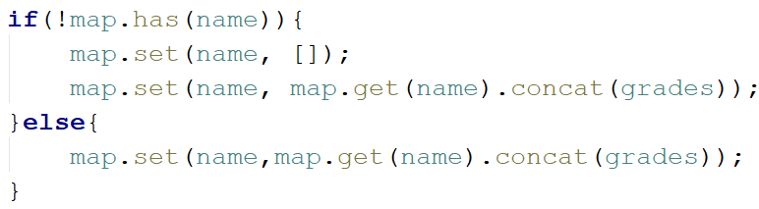

* If we **don’t have** the name, we need to **create it** and **concatenate [**concat()**]** the empty array and the new one
* Otherwise, we justconcat()them

Now we have to sort them by average grades:



Of course, there is no such function average, so we need to create it.

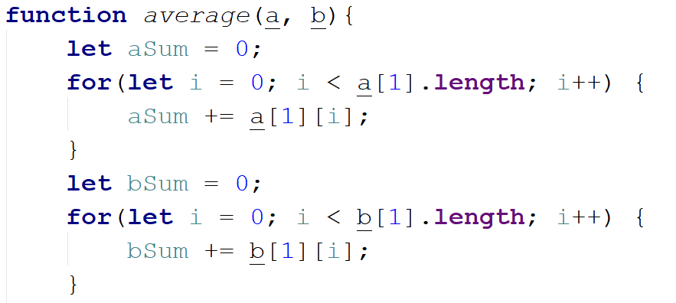

* a and b are two key-value pairs of our map. The grades are the values.
* For us to calculate average we need to take the sum and divide it by the length of each array

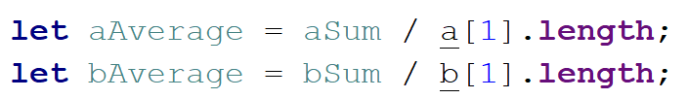

Finally, we return aAverage – bAverage:

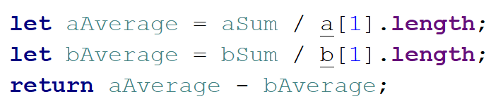

We sorted the map, now loop through the keys and values and print them in the format from the example.

## Word Occurrences

Write a function that **counts** the times each **word occurs** in a text. Print the words **sorted by count** in **descending** order. The input comes as an **array of strings**.

### Example

|  |  |
| --- | --- |
| **Input** | **Output** |
| **["Here", "is", "the", "first", "sentence", "Here", "is", "another", "sentence", "And", "finally", "the", "third", "sentence"]** | **sentence -> 3 times**  **Here -> 2 times**  **is -> 2 times**  **the -> 2 times**  **first -> 1 times**  **another -> 1 times**  **And -> 1 times**  **finally -> 1 times**  **third -> 1 times** |
| **["dog", "bye", "city", "dog", "dad", "boys", "ginger"]** | **dog -> 2 times**  **bye -> 1 times**  **city -> 1 times**  **dad -> 1 times**  **boys -> 1 times**  **ginger -> 1 times** |

### Hint

* Create a map
* Loop through the elements of the array of words
* Update the map
* Sort the map by value in descending:



* Finally, print the result in format as the example above

## Neighborhoods

Write a function that receives **list of neighborhoods** and then some **people**, who are going to live in it. The **input** will come as **array of strings**. The **first element** will be the list of neighborhoods **separated** by **", "**. The rest of the element**s** will be a neighborhood followed by a **name** of a person in the format **"**{neighborhood} - {person}**"**. **Add** theperson to the neighborhood **only** if the neighborhood is inthe **list** of neighborhoods. At the end print the neighborhoods **sorted** by the count of inhabitants in descending order. Print them in the following format:

"{neighborhood}: {inhabitants count}

--{1st inhabitant}

--{2nd inhabitant}

…"

### Example

|  |  |
| --- | --- |
| **Input** | **Output** |
| **['Abbey Street, Herald Street, Bright Mews',**  **'Bright Mews - Garry',**  **'Bright Mews - Andrea',**  **'Invalid Street - Tommy',**  **'Abbey Street - Billy']** | **Bright Mews: 2**  **--Garry**  **--Andrea**  **Abbey Street: 1**  **--Billy**  **Herald Street: 0** |
| **['Abbey Street, Herald Street, Bright Mews',**  **'Herald Street - Keity',**  **'Abbey Street – Liam',**  **'Bright Mews - Mark',**  **'Abbey Street – John']** | **Abbey Street: 2**  **--Liam**  **--John**  **Herald Street: 1**  **--Keity**  **Bright Mews: 1**  **--Mark** |

### Hints

* **Save** the first element of the array as the neighborhoods
* **Fill** the map with them and set their values as empty arrays
* **Loop** through the rest of the elements
* **Check** if the neighborhood is in the list/map and add the person
* **Sort** them by count of inhabitants
* **Print**

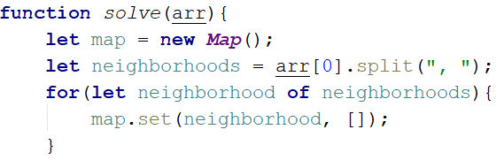

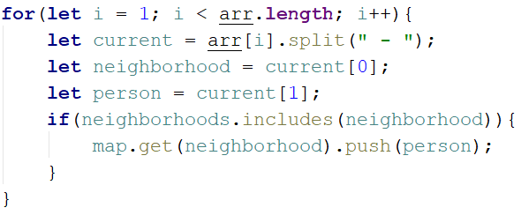

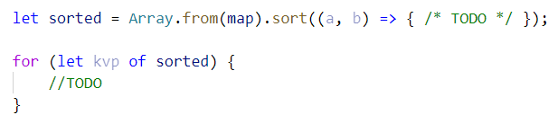

* ***NOTE:*** The count of the people is the length of the second element in both aand b**.** To sort in descending, just **subtract** the length of a inhabitance from the lengthof thebinhabitants.